Data Communications and Networking
Lab 3 – Routing
Calum Murray (H00402826)

Part 1 (Topology):
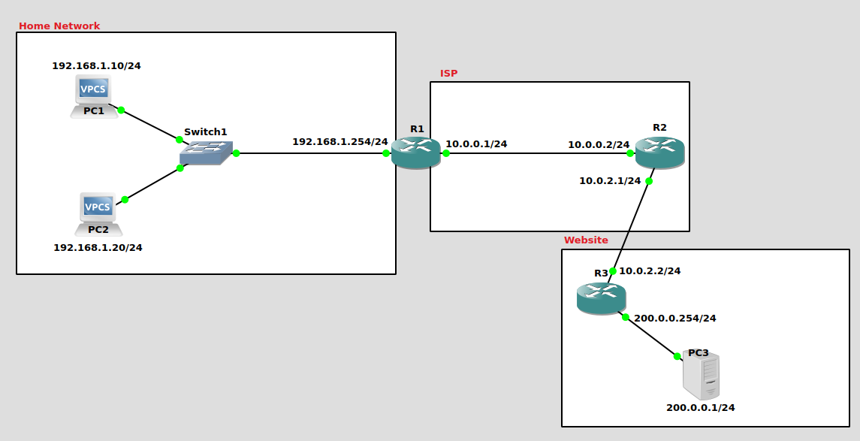

Topology created as per instruction.
Host addresses assigned to VPC’s and router interface ports as per instruction.

Part 2 (Static Routing):
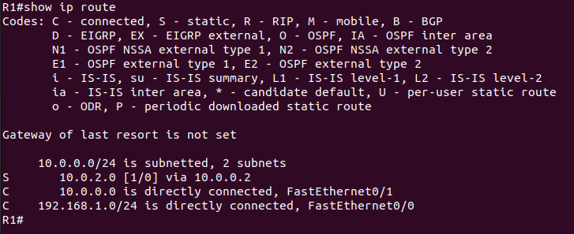

1st Gateway created on R1, accessing 10.0.2.0 from R2 fastEthernet interface 10.0.0.2
Q1: If you only configure R1 with the command (ip route 10.0.2.0 255.255.255.0 10.0.0.2), does a ping from PC1 to R2 work? Why?
A1: This DOESN’T ping as intended, because R2 doesn’t have an established route to send a respond message back to PC1
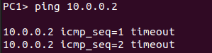

Resolution: By establishing a static route from R2 to the 192.168.1.0 network, a ping response can be sent once it is received from PC1
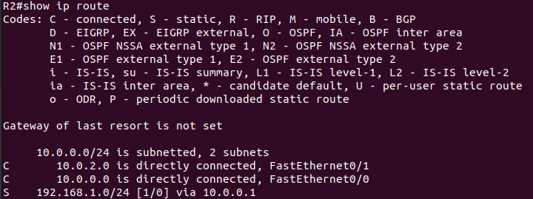

This provides a static route for R2 to respond to the ping from PC1
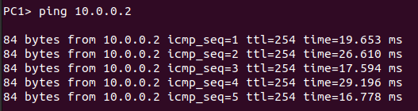

I now set up the static routes on each router
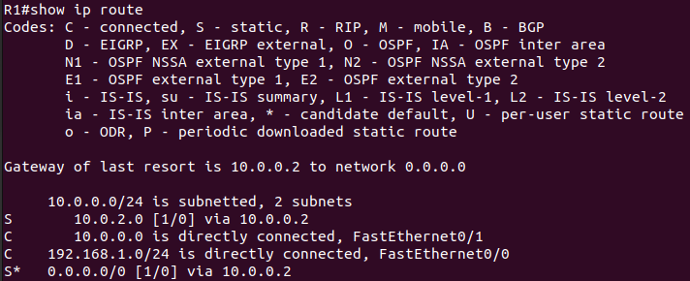

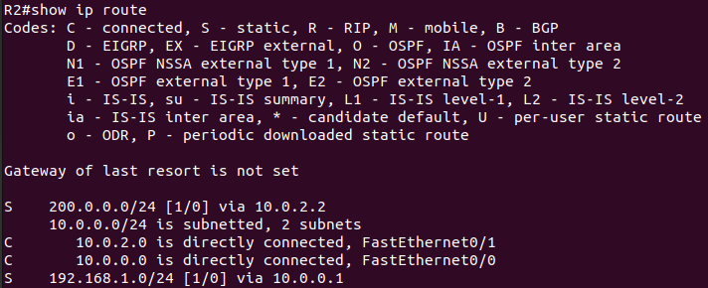

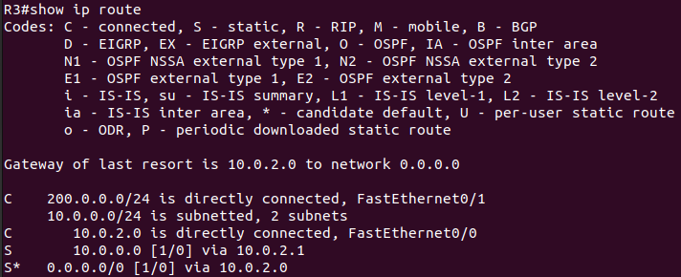

Link between PC1 and PC2 established
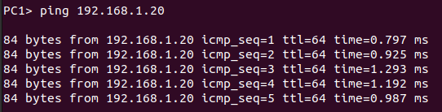
_{Ping between PC1-PC2}

Link between PC1 and PC3 established
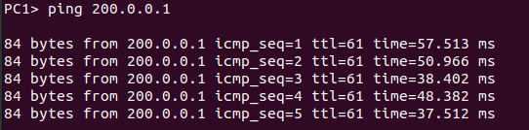
_{Ping between PC1-PC3}

Link between PC2 and PC3 established
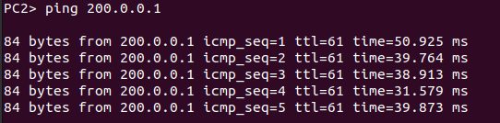
_{Ping between PC2-PC3}

Part 3: RIP
Q2: What do you notice about the RIP packets?
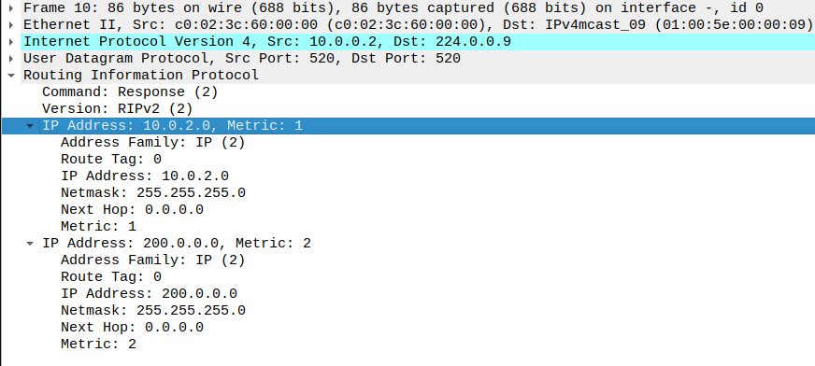

A2: Sends a packet that outlines what networks the source has access to and the hop count(Metric: x) needed to access it from the souce.

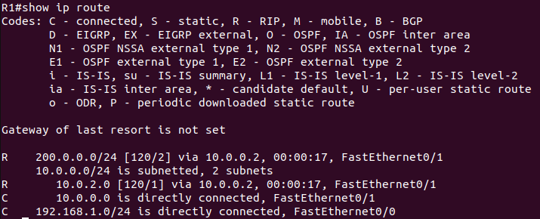
_{R1 routing table}
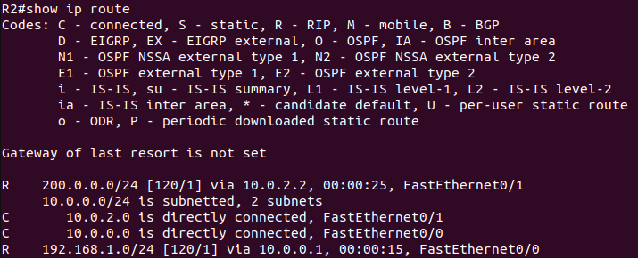
_{R2 routing table}

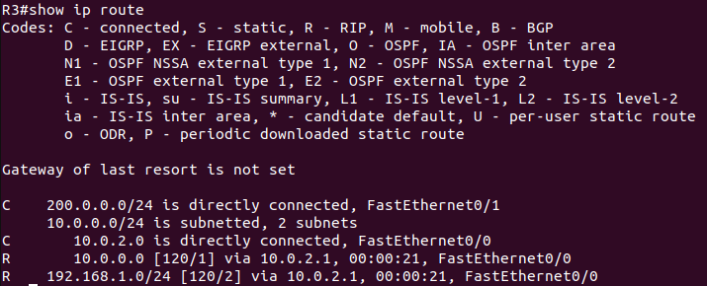
_{R3 routing table}

